Call for Nominations: Virchow Prize for Global Health

Communications toolkit
May 2022

- BACKGROUND

The Virchow Prize for Global Health is a major international award of high prestige that honours outstanding achievements in addressing the global health challenges we face today. Established by the Virchow Foundation for Global Health, the Virchow Prize for Global Health is awarded annually in Berlin, with the first ceremony held on 15 October 2022.

To support the launch of this new prize, we would love your support in amplifying the call for nominations on social media and through your newsletters. This toolkit includes resources the you can adapt and use as needed.

Links to the Nomination page
English: https://virchowprize.org/nominations/
German: https://virchowprize.org/de/nomination/

Links to the launch press release on April 1
English: https://virchowprize.org/virchow-prize-for-global-health-launched/
German: https://virchowprize.org/de/virchow-preis-fuer-globale-gesundheit-ausgeschrieben/

- VIRCHOW PRIZE FOR GLOBAL HEALTH SOCIAL CHANNELS
We will be regularly sharing information about the nomination process on our channels. Please feel free to retweet, share and engage with our posts.
- Twitter: @virchowprize
- LinkedIn: https://www.linkedin.com/company/virchowprize/

- SOCIAL MEDIA CONTENT
The sample posts can be adapted as needed. Please tag Virchow Prize in your posts, so we can be notified and like/share them in a timely manner.

SUGGESTED SOCIAL MEDIA POSTS
Call for nominations: the @virchowprize will award €500K for lifetime achievements towards improving health & well-being for all
Deadline: June 30, 2022 https://virchowprize.org/nominations/

We are excited to share the @virchowprize which awards €500K for outstanding achievements towards improving health & well-being for all. Deadline for nominations is June 30. Please repost!
https://virchowprize.org/nominations/

Do you know an individual or organisation who has devoted their work to improving #globalhealth?
The @virchowprize awards €500K for outstanding achievements towards improving health & well-being for all
Deadline: June 30, 2022
https://virchowprize.org/nominations/

Call for nominations: the international Virchow Prize for Global Health will award laureates €500,000 for their longstanding commitment towards improving health and well-being for all. The Virchow Prize is awarded annually in Berlin, with the inaugural ceremony held 15 October 2022.

Deadline for submissions: June 30
All information on the nomination process can be found here: https://virchowprize.org/nominations/

Do you know an individual or organisation who has devoted their work to improving #globalhealth? Laureates of the Virchow Prize for Global Health will be awarded €500,000 for their longstanding commitment towards improving health and well-being for all.

All information on the nomination process can be found here: https://virchowprize.org/nominations/

Deadline for submissions: June 30, 2022

- SUGGESTED NEWSLETTER TEXT

Call for Nominations: Virchow Prize for Global Health

We are delighted to introduce to our partners, the Virchow Prize for Global Health. For the first time this year, the Virchow Prize for Global Health will be awarded on 15 October in Berlin. Laureates of the Virchow Prize for Global Health will be awarded an endowment of €500,000 for their longstanding commitment and contributions towards improving health and well-being for all.

The nomination phase is now open through 30 June 2022. All information on the nomination process can be found here: https://virchowprize.org/nominations/

Read the full press release: https://virchowprize.org/virchow-prize-for-global-health-launched/

Stay up to date by subscribing to the Virchow Prize for Global Health newsletter here and follow on Twitter and LinkedIn

- SUGGESTED VISUAL

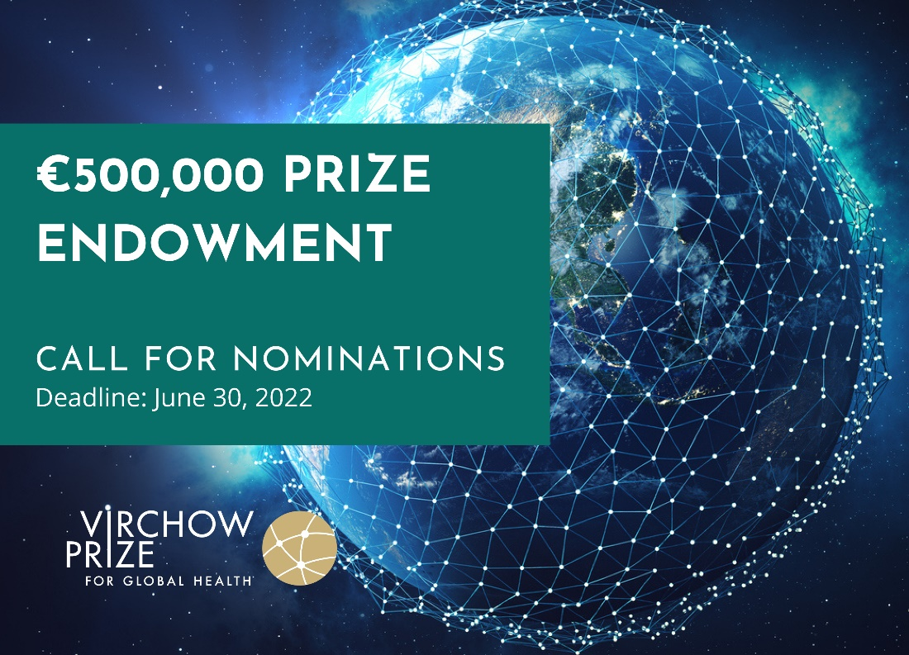

For more information, please contact Victoria Grandsoult, Managing Director, Virchow Foundation for Global Health: grandsoult@virchow.foundation

