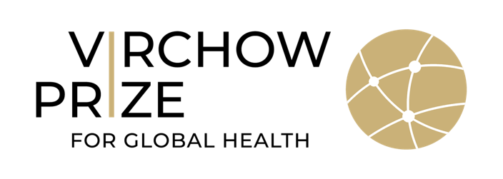

2022 Virchow Prize for Global Health

Communications toolkit
September 2022

About the Virchow Prize for Global Health
The Virchow Prize for Global Health is awarded annually in Berlin, with the first ceremony held on October 15, 2022. www.virchowprize.org
The Virchow Prize for Global Health recognizes and celebrates innovations with significant impact on the broad health challenges we face as a global community, while upholding the United Nations 2030 Sustainable Development Goals. With this award, lifetime achievements towards "Health for All” are honoured.
Established by the Virchow Foundation for Global Health in October 2021, the Virchow Prize for Global Health aims to incentivize and spur future generations of great minds in their commitment to global health. Endowed with €500,000, this prestigious award recognizes individuals or organisations who dedicate their lives to improving global health – whether through academic, political, social, economic, or industrial innovation.

Overview of the Virchow Prize for Global Health Ceremony
Date
- Saturday, October 15, 2022

Venue
- Marriott Hotel, Berlin Central District
Rudolf Virchow Room (Grand Ballroom)
Stauffenbergstraße 26, 10785 Berlin, Germany
- Livestream

Participation
- On-site participation: Please register beforehand
- Online participation: No prior registration required. A livestream will be available

Speakers
- Stéphanie Seydoux, Master of Ceremony
- Franziska Giffey, Governing Mayor, City of Berlin
- Professor Dr Gerald Haug, President, Virchow Foundation for Global Health
- Dr Tedros Adhanom Ghebreyesus, Director-General, World Health Organization
- 2022 Virchow Prize for Global Health Laureate(s)
- Dr Friede Springer, Co-Founder, Virchow Foundation for Global Health
- Professor Dr Christoph Markschies, Co-Founder, Virchow Foundation for Global Health
- Professor Dr Detlev Ganten, Co-Founder, Virchow Foundation for Global Health
- Roland Göhde, Co-Founder, Virchow Foundation for Global Health

High Patronage
- Frank-Walter Steinmeier, President, Federal Republic of Germany

Participants
- Laureate(s) and their invited guests
- Virchow Foundation for Global Health: Founders, Members of the Board of Trustees, Council, and Virchow Prize Committee
- Leading scientists, medical professionals, global health activists
- Ambassadors, ministers, and civil servants
- High-ranking officials of international organisations
- CEOs from industry and civil society
- Young professionals
- Journalists and media

Goals
- Awarding the first laureate(s) of the Virchow Prize for Global Health
- Honouring and celebrating their lifetime achievements and devotion to improving global health, achieving the United Nations Sustainable Development Goals and “Health for All”
- Raising awareness on the importance health as a crucial determining factor for a quality life by highlighting the men and women who dedicate their lives to this essential work.

Useful Links
- Registration Virchow Prize Award Ceremony
- Information on the Virchow Foundation for Global Health and the Virchow Prize
- United Nations – Sustainable Development Goals
- Article Public Health – Then and Now: Virchow, The Heroic Model in Medicine: Health Policy by Accolade
- Rudolf Virchow and the Humboldt University of Berlin
- A brief history of the Institute of the History of Medicine and Ethics in Medicine of the Charité - Universitätsmedizin (German version only)

Virchow Foundation for Global Health Social Media Accounts
- Twitter @virchowprize
- LinkedIn Virchow Prize for Global Health
- YouTube Virchow Foundation for Global Health
- Newsletter Virchow Foundation for Global Health
- Hashtag: #VirchowPrize2022

2022 Virchow Prize for Global Health Laureate Announcement
Press Release
- English version
- German version

Video stream

2022 Virchow Prize for Global Health Portrait

Social Media Content
The sample posts can be adapted as needed. Please tag Virchow Prize in your posts, so we can be notified and like/share them in a timely manner.

Suggested Social Media Posts

The @virchowprize awards €500K for lifetime achievements towards improving health & well-being for all.

It recognizes and celebrates innovations with significant impact on the broad health challenges we face as a global community.

Learn more: https://bit.ly/3TEJi9z

The Virchow Foundation for Global Health will award the first @virchowprize October 15 in Berlin. Endowed with €500K, this prestigious prize honours lifetime achievements in #globalhealth

Register for the #VirchowPrize2022 Award Ceremony here https://bit.ly/3I2hG8K

The 2022 @virchowprize for Global Health laureate is announced! Endowed with €500K, Dr John N. Nkengasong is honoured for his significant, lifetime contributions to #globalhealth & #HealthForAll

Rewatch the announcement: https://youtu.be/JR-_nM4N2Qg
#VirchowPrize2022

The 2022 Virchow Prize for Global Health is announced! Endowed with €500K, Dr John N Nkengasong is honoured for his longstanding commitment towards improving health and well-being for all.

Rewatch the announcement: https://youtu.be/JR-_nM4N2Qg

Register for the #VirchowPrize2022 Award Ceremony https://bit.ly/3I2hG8K
October 15, 2022 | 18:00-19:30 CET | Berlin
Relevant branding

Logo Virchow Prize for Global Health

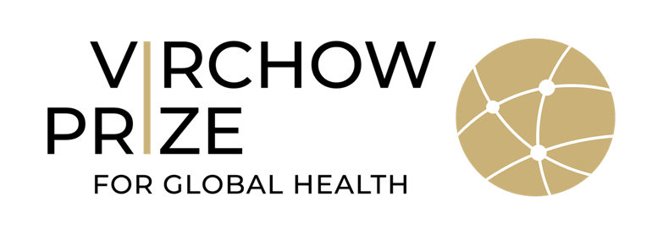

Logo Virchow Foundation for Global Health

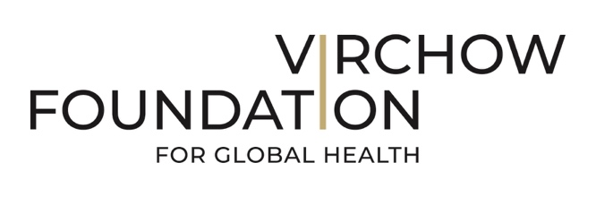

Press Contact
The download may be used free of charge, provided that the copyright is acknowledged. The use for party-political events or publications as well as a transfer to third parties is not permitted. The use for commercial purposes requires a prior written agreement.

For more information, please contact Steffi Gasteiger, Communication & Partnerships Manager, Virchow Foundation for Global Health
steffi.gasteiger@virchow.foundation / press@virchow.foundation

