Call for Nominations
Virchow Prize for Global Health

Communications toolkit
November 2023

About the Virchow Prize for Global Health

The Virchow Prize for Global Health was awarded for the first time in 2022 under the High Patronage of German Federal President, Frank-Walter Steinmeier. Endowed with €500,000, the Virchow Prize recognises outstanding lifetime achievements in the field of global health that align and uphold the Sustainable Development Goals of the United Nations 2030 Agenda.
2022 Virchow Prize for Global Health Laureate Portrait – John N. Nkengasong
2022 Virchow Prize for Global Health Award Ceremony livestream available via our YouTube channel: https://youtu.be/AAvPuEWyMSs
The Virchow Prize for Global Health is awarded by the Virchow Foundation for Global Health, an independent non- profit foundation under civic law. Based in Berlin and Münster, the Virchow Foundation for Global Health was established with the support of the German National Academy of Sciences Leopoldina and Berlin-Brandenburg Academy of Sciences and Humanities, alongside civil society, and leading experts within global health, to contribute to the improvement of health worldwide. Further information: https://virchowprize.org
To support the opening of the nomination phase for the 2023 Virchow Prize for Global Health, we would love your support in amplifying the call for nominations on social media and through your newsletters. This toolkit includes resources you can adapt and use as needed.

Links to the Nomination page
English: https://virchowprize.org/nominations/
German: https://virchowprize.org/de/nomination/
Download the Nomination form
Links to the press release announcing the nomination phase
English: https://virchowprize.org/2023-virchow-pri…-open-november-1/
German: https://virchowprize.org/de/virchow-foundati…rchow-preis-2023/

Virchow Prize for Global Health Social Media Accounts
- Twitter @virchowprize
- LinkedIn Virchow Prize for Global Health
- YouTube Virchow Foundation for Global Health
- Newsletter Virchow Foundation for Global Health
- Hashtag: #VirchowPrize2023

Social Copies
These sample posts can be adapted as needed. Please tag #VirchowPrize2023 in your posts, so we can be notified and like/share them in a timely manner.

SUGGESTED SOCIAL MEDIA POSTS

Call for nominations!
Delighted to support the #VirchowPrize2023, providing a powerful platform to increase awareness of the crucial importance of #globalhealth
Information on nominations: https://bit.ly/3fj0JwP
_____________________________________________________________________________________________
Nomination phase for the #VirchowPrize2023 has officially begun. Please share in your networks to engage participation for this prestigious recognition in #globalhealth.
More information on the nomination process: https://bit.ly/3fj0JwP
_____________________________________________________________________________________________
Let us continue to increase awareness of the crucial importance of #globalhealth together.
Submit your nominations for the #VirchowPrize2023
Find more information on eligibility criteria & the nomination process: https://bit.ly/3fj0JwP
_____________________________________________________________________________________________
Call for nominations: the @virchowprize awards €500k for outstanding lifetime achievements towards #HealthForAll
Find more information on the nomination process: https://bit.ly/3fj0JwP
_____________________________________________________________________________________________
Do you know an individual or organisation who has devoted their work to improving #globalhealth?
The @virchowprize awards €500K for outstanding achievements towards improving #HealthForAll
https://bit.ly/3fj0JwP
_____________________________________________________________________________________________

Call for nominations: the international Virchow Prize for Global Health awards laureates €500,000 for their longstanding commitment towards improving health and well-being for all. The Virchow Prize is awarded annually in Berlin, with the next ceremony held October 14, 2023.
Deadline: March 31, 2023
All information on the nomination process and eligibility criteria can be found here: https://virchowprize.org/nominations/
@Virchow Foundation for Global Health
_____________________________________________________________________________________________
Nomination phase for the 2023 Virchow Prize for Global Health begins today! Endowed with €500,000 the Prize honours laureates for their outstanding lifetime contributions to #HealthForAll
Nominations may be submitted from November 1, 2022 through March 31, 2023.
Find more information on eligibility criteria, qualified nominators, and the nomination process: https://virchowprize.org/nominations/
Please share with your networks!
Read the press release: https://virchowprize.org/2023-virchow-pri…-open-november-1/
_____________________________________________________________________________________________
Call for Nominations: 2023 @Virchow Prize for Global Health

We are delighted to announce the 2023 Virchow Prize for Global Health nomination phase has officially begun. For the second time, the Virchow Prize for Global Health will be awarded on October 14, 2023 in Berlin.

Laureates of the #VirchowPrize2023 will be awarded an endowment of €500,000 for their longstanding commitment and contributions towards improving #HealthForAll.

Deadline to nominate: March 31, 2023

More information on the nomination process and eligibility criteria: ttps://virchowprize.org/nominations/

Read the full press release: https://virchowprize.org/2023-virchow-pri…-open-november-1/
Please share with your networks!
@Virchow Foundation for Global Health

SUGGESTED NEWSLETTER TEXT
Call for Nominations: 2023 Virchow Prize for Global Health

We are delighted to announce to our partners, the 2023 Virchow Prize for Global Health nomination opened November 1, 2022 and runs through March 31, 2023. For the second time, the Virchow Prize for Global Health will be awarded on October 14, 2023 in Berlin. Laureates of the Virchow Prize for Global Health will be awarded an endowment of €500,000 for their longstanding commitment and contributions towards improving ‘Health for All’.

Deadline to nominate is March 31, 2023. More information on the nomination process and eligibility criteria: ttps://virchowprize.org/nominations/

Read the full press release: https://virchowprize.org/2023-virchow-pri…-open-november-1/

Stay up to date by subscribing to the Virchow Prize for Global Health newsletter, and follow on Twitter, LinkedIn and YouTube.

SUGGESTED E-MAIL TEXT
Dear colleagues,
I am writing to introduce the Virchow Prize for Global Health and kindly request your support in spreading the word to call for nominations.
The Virchow Prize for Global Health is an international award which honours lifetime achievements towards improving health and wellbeing for all. Endowed with €500,000, the call for nominations is now open through March 31, 2023. The fist Virchow Prize was awarded to Dr John N. Nkengasong on October 15 in Berlin in the presence of several hundred distinguished international guests from the global health community, diplomats, political leaders, and scientists from all over the world. Highlights from the ceremony can be viewed here.
The Virchow Prize is awarded by the Virchow Foundation for Global Health, a non-profit foundation established through the support of the German National Academy of Sciences Leopoldina and the Berlin-Brandenburg Academy of Sciences and Humanities, alongside civil society and leading experts within global health.
Considering the relevance of the Virchow Prize amongst your network, we would be delighted to receive your help in amplifying the call for nominations on social media and through your newsletters. If you agree, please find included a toolkit with resources and text which you are welcome to adapt and use as needed as well as the 2023 Nomination Form.
Please also find all information on the nomination process online at: https://virchowprize.org/nominations/
Thank you in advance and please do let me know if I can provide any additional information.
Sincerely,

Useful Links
- Information on the Virchow Foundation for Global Health and the Virchow Prize
- United Nations – Sustainable Development Goals
- Rudolf Virchow – brief documentary
- Article Public Health – Then and Now: Virchow, The Heroic Model in Medicine: Health Policy by Accolade

Suggested Visuals
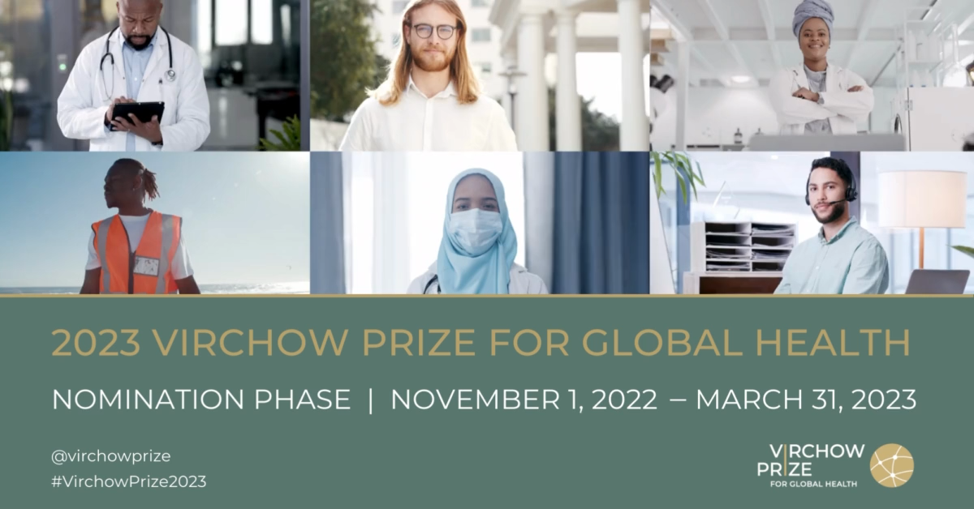
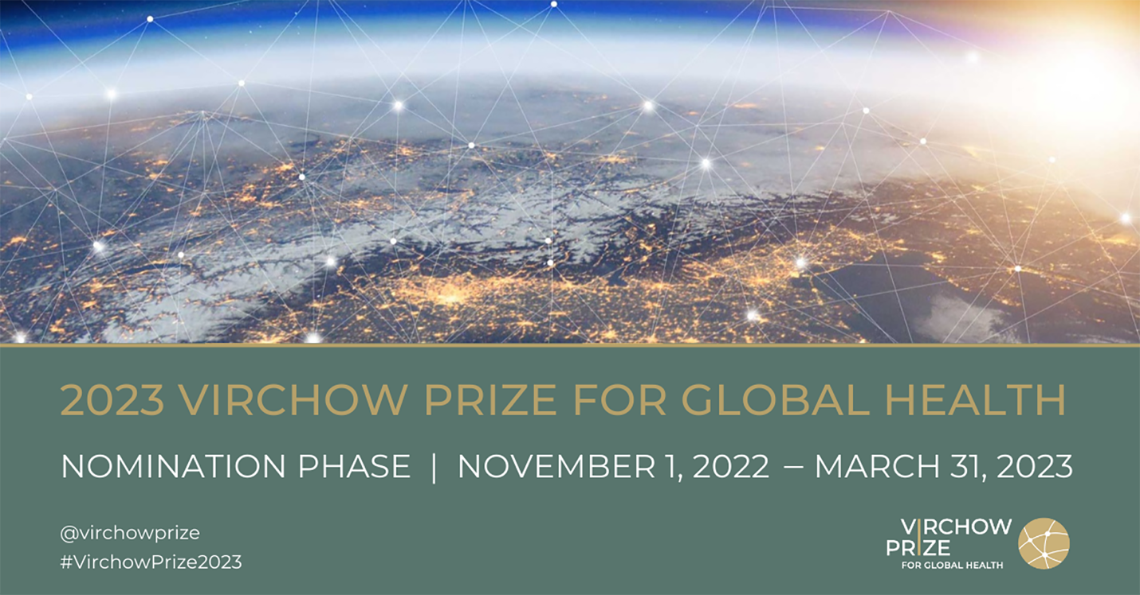

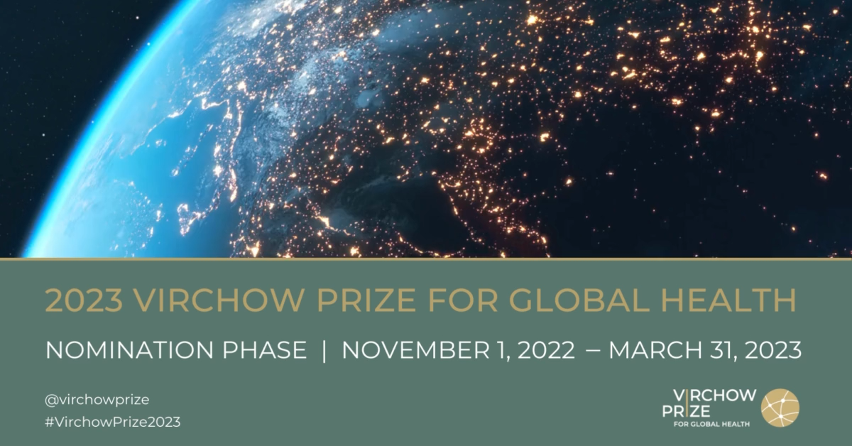

Virchow Prize for Global Health Logos
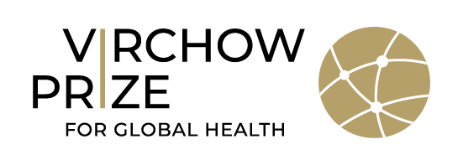
(Black text)
(White text)

Press Contact
For more information and/or material, please contact Steffi Gasteiger, Communication & Partnerships Manager, Virchow Foundation for Global Health
steffi.gasteiger@virchow.foundation / press@virchow.foundation

