Call for Nominations
Virchow Prize for Global Health

Communications toolkit
November 2023

About the Virchow Prize for Global Health

The Virchow Prize for Global Health was awarded for the first time in 2022 under the High Patronage of German Federal President, Frank-Walter Steinmeier. The Virchow Prize recognises outstanding lifetime achievements in the field of global health that align and uphold the Sustainable Development Goals of the United Nations 2030 Agenda.
2023 Virchow Prize for Global Health Laureate Portrait – Rose Gana Fomban Leke
2023 Virchow Prize for Global Health Award Ceremony livestream available soon on our website or watch captivating highlights.
The Virchow Prize for Global Health is awarded by the Virchow Foundation for Global Health, an independent non- profit foundation under civic law. Based in Berlin and Münster, the Virchow Foundation for Global Health was established with the support of the German National Academy of Sciences Leopoldina and Berlin-Brandenburg Academy of Sciences and Humanities, alongside civil society, and leading experts within global health, to contribute to the improvement of health worldwide. Further information: https://virchowprize.org
To support the opening of the nomination phase for the 2024 Virchow Prize for Global Health, we would love your support in amplifying the call for nominations on social media and through your newsletters. This toolkit includes resources you can adapt and use as needed.

Links to the Nomination page
English
German
Download the Nomination form
Links to the press release announcing the nomination phase
English
German

Virchow Prize for Global Health Social Media Accounts
- Twitter @virchowprize
- LinkedIn Virchow Prize for Global Health
- YouTube Virchow Foundation for Global Health
- Newsletter Virchow Foundation for Global Health
- Hashtag: #VirchowPrize2024

Social Copies
These sample posts can be adapted as needed. Please tag #VirchowPrize2024 in your posts, so we can be notified and like/share them in a timely manner.

SUGGESTED SOCIAL MEDIA POSTS
X / formerly Twitter
Call for nominations!
Delighted to support the #VirchowPrize2024, providing a powerful platform to increase awareness of the crucial importance of #globalhealth
Information on nominations: https://bit.ly/3RZ9Svs
_____________________________________________________________________________________________
Nomination phase for the #VirchowPrize2024 is open! Please share in your networks to engage participation for this prestigious recognition in #globalhealth.
More information on the nomination process: https://bit.ly/3RZ9Svs
_____________________________________________________________________________________________
Let us continue to increase awareness of the crucial importance of #globalhealth together.
Submit your nominations for the #VirchowPrize2024
Find more information on eligibility criteria & the nomination process: https://bit.ly/3RZ9Svs
_____________________________________________________________________________________________
Call for nominations: the @virchowprize honours outstanding lifetime achievements towards #HealthForAll
Find more information on the nomination process: https://bit.ly/3RZ9Svs
_____________________________________________________________________________________________
Do you know an individual or organisation who has devoted their work to improving #globalhealth?
The @virchowprize honours outstanding achievements towards improving #HealthForAll
https://bit.ly/3RZ9Svs
_____________________________________________________________________________________________
LinkedIn
Call for nominations!
Laureates of the international Virchow Prize for Global Health are awarded for their longstanding commitment towards improving health and well-being for all.
Deadline to submit your nominations | February 29, 2024
All information on the nomination process and eligibility criteria can be found here: https://virchowprize.org/nominations/
@Virchow Foundation for Global Health
_____________________________________________________________________________________________
Nomination phase for the 2024 Virchow Prize for Global Health is open until February 29, 2024!
This international Prize honours laureates for their outstanding lifetime contributions towards #HealthForAll
Find more information on eligibility criteria, qualified nominators, and the nomination process: https://virchowprize.org/nominations/
Please share with your networks!
SUGGESTED NEWSLETTER TEXT
Call for Nominations: 2024 Virchow Prize for Global Health

We are delighted to announce to our partners, the 2024 Virchow Prize for Global Health nomination opened October 14, 2023 and runs through February 29, 2024. For the third time, the Virchow Prize for Global Health will be awarded with the festive award ceremony held on October 12, 2024 in Berlin.

Laureates of the Virchow Prize for Global Health will be awarded for their longstanding commitment and contributions towards improving ‘Health for All’.

Deadline to nominate is February 29, 2024. More information on the nomination process and eligibility criteria can be found: www.virchowprize.org/nominations/

Read the full press release here

Stay up to date by subscribing to the Virchow Prize for Global Health newsletter, and follow on X / Twitter, LinkedIn, YouTube and Instagram.

SUGGESTED E-MAIL TEXT
Dear colleagues,
I am writing to introduce the Virchow Prize for Global Health and kindly request your support in spreading the word to call for nominations.
The Virchow Prize for Global Health is an international award which honours lifetime achievements towards improving health and wellbeing for all. The call for nominations is now open through February 29, 2024.
The 2023 Virchow Prize was awarded to Professor Rose Gana Fomban Leke on October 14 in the Rotes Rathaus Berlin (City Hall) in the presence of 250 distinguished international guests from the global health community, diplomats, political leaders, and scientists from all over the world. Highlights from the ceremony can be viewed here.
The Virchow Prize is awarded by the Virchow Foundation for Global Health, a non-profit foundation established through the support of the German National Academy of Sciences Leopoldina and the Berlin-Brandenburg Academy of Sciences and Humanities, alongside civil society and leading experts within global health.
Considering the relevance of the Virchow Prize amongst your network, we would be delighted to receive your help in amplifying the call for nominations on social media and through your newsletters. If you agree, please find included a toolkit with resources and text which you are welcome to adapt and use as needed as well as the 2024 Nomination Form.
Please also find all information on the nomination process and eligibility criteria online at: https://virchowprize.org/nominations/
Thank you in advance and please do let me know if I can provide any additional information.
Sincerely,
_____________________________________________________________________________________________
Useful Links
- Information on the Virchow Foundation for Global Health and the Virchow Prize
- United Nations – Sustainable Development Goals
- Rudolf Virchow – brief documentary
- Article Public Health – Then and Now: Virchow, The Heroic Model in Medicine: Health Policy by Accolade
- Journal of Public Health in Africa | A prize for global health in the name of Virchow

Suggested Visuals
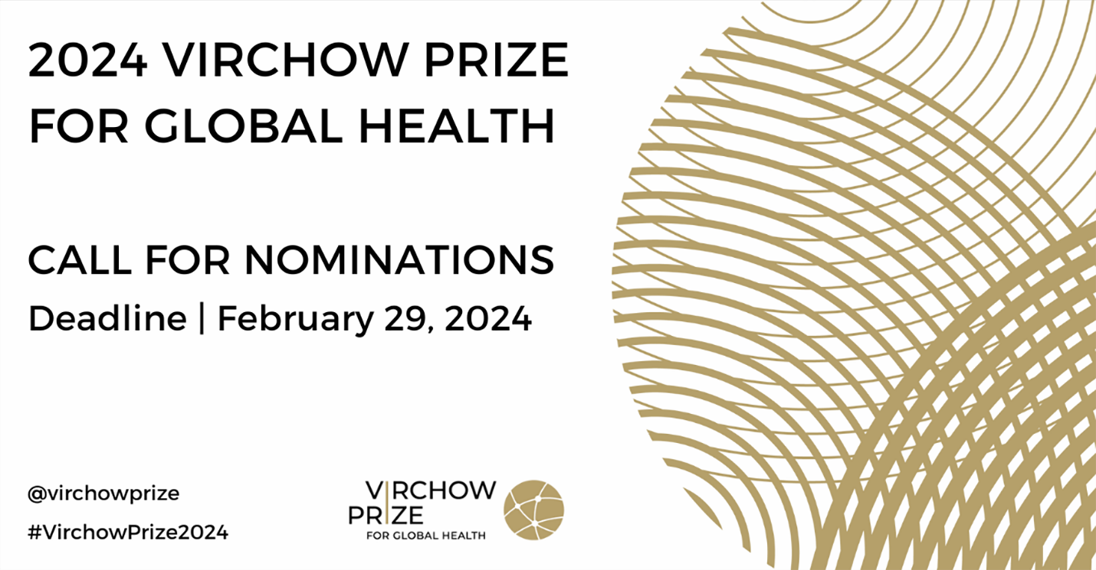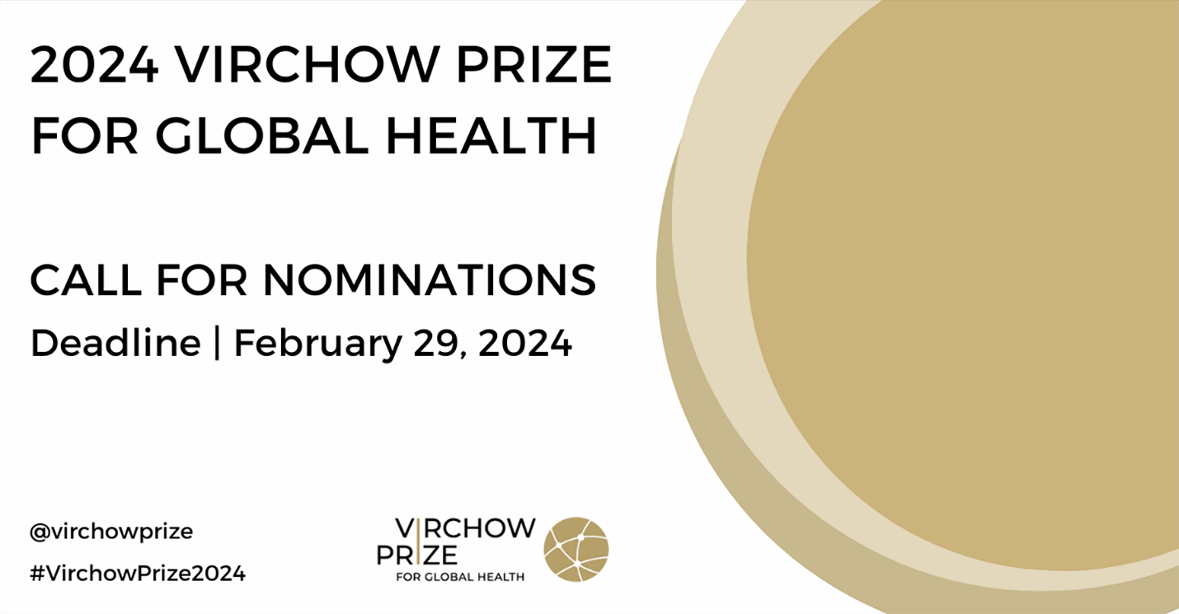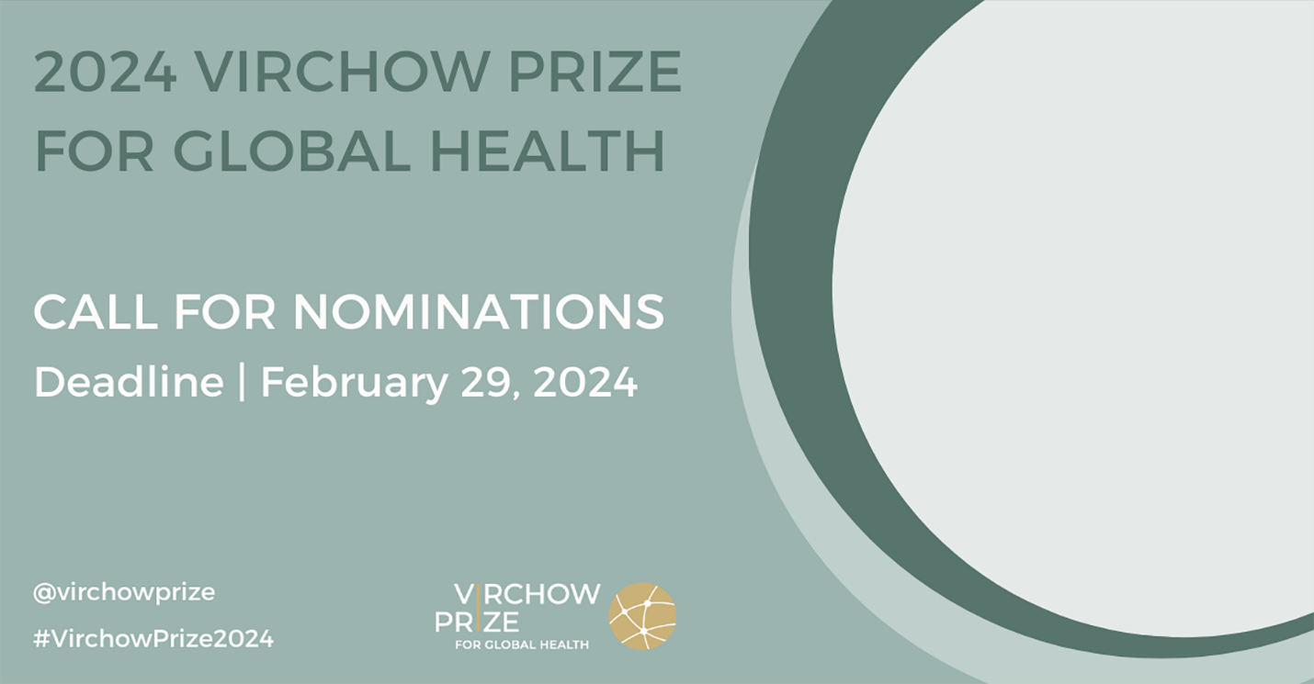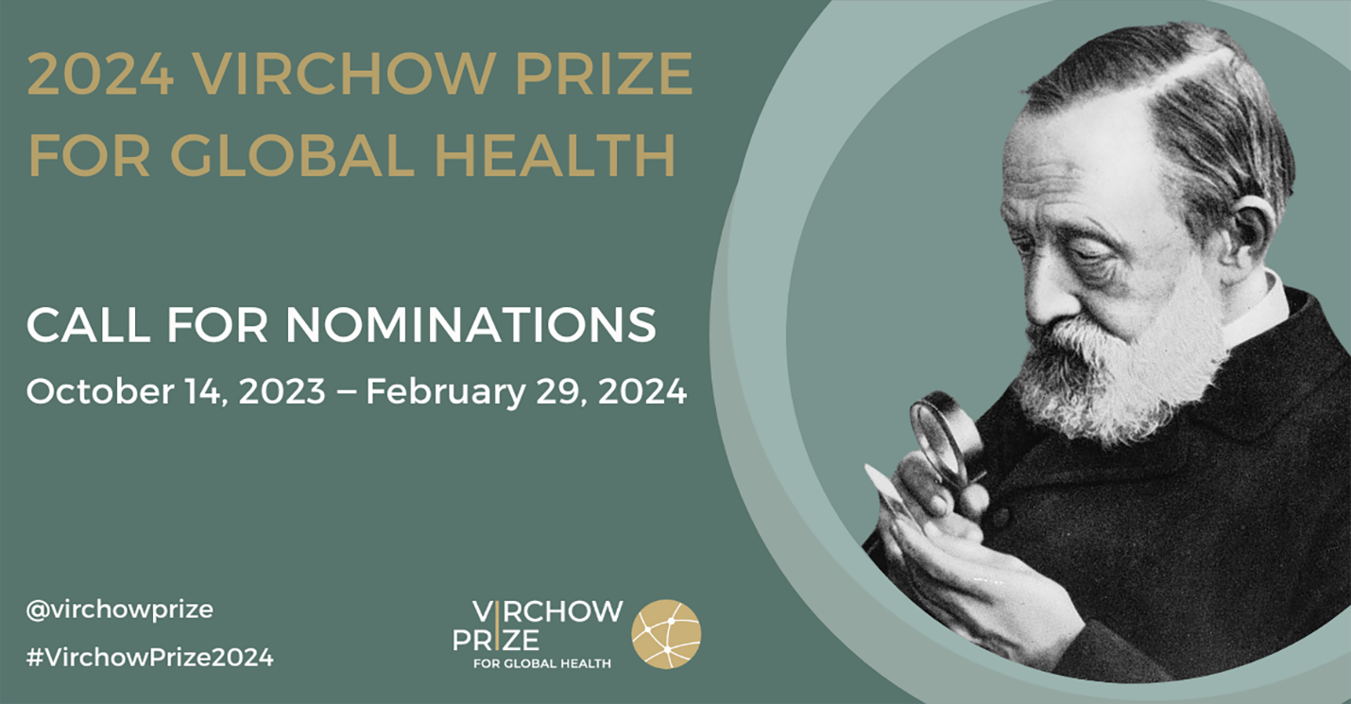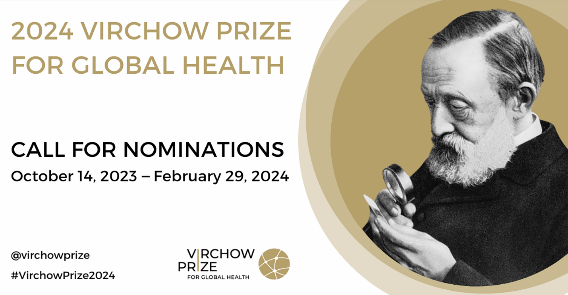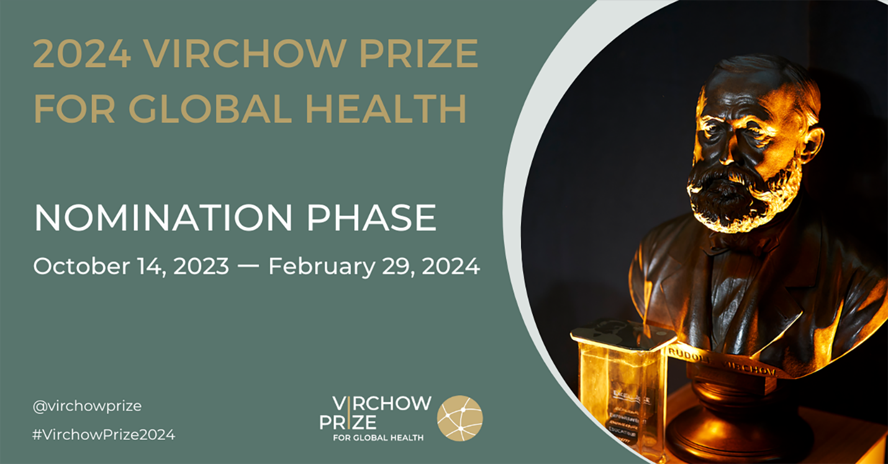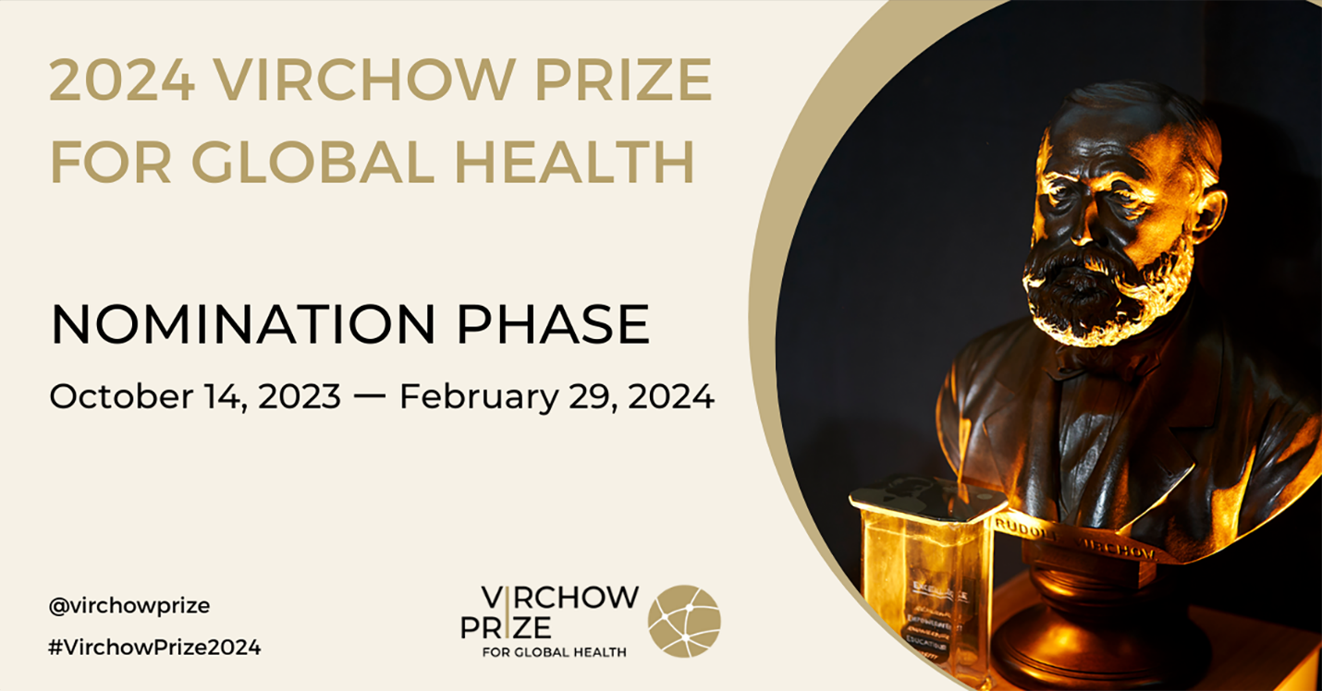

Virchow Prize for Global Health Logos
(Black text)
(White text)

Press Contact
For more information and/or material, please contact Steffi Gasteiger, Communication & Partnerships Manager, Virchow Foundation for Global Health
steffi.gasteiger@virchow.foundation / press@virchow.foundation

