Call for Nominations
The Virchow Prize 2025

Communications toolkit
October 2024

About the Virchow Prize
The Virchow Prize recognises outstanding lifetime achievements in the field of global health that align and uphold the Sustainable Development Goals of the United Nations 2030 Agenda. With this award, innovations with significant impact on the broad health challenges we face as a community are honoured.
The award is endowed by the Virchow Foundation, an independent non-profit foundation under civic law. Based in Berlin and Münster, the Virchow Foundation was established jointly with support of the Presidents of the German National Academy of Sciences Leopoldina and Berlin-Brandenburg Academy of Sciences and Humanities, alongside civil society, and leading experts within global health, to contribute to the improvement of health worldwide.
The inaugural Virchow Prize was awarded in 2022 under the High Patronage of German Federal President, Frank-Walter Steinmeier to John N. Nkengasong. He was celebrated on Saturday, October 15, 2022, for his outstanding lifetime achievements towards improving health access for the world’s most vulnerable. Learn more about Ambassador Dr. John Nkengasong and watch highlights of the captivating ceremony.
On the occasion of the first award ceremony, the German Bundestag discussed the Virchow Prize in a plenary debate and in this context reaffirmed their commitment and support for achieving the Sustainable Development Goals (SDGs) and the 2030 Agenda.
Professor Rose Gana Fomban Leke received the 2023 Virchow Prize on Saturday, October 14, 2023, at the Rotes Rathaus (Berlin City Hall) under high patronage of the President of the German Bundestag, Bärbel Bas. The Virchow Prize Committee recognised Rose Leke’s pioneering infectious disease research towards a malaria-free world and relentless dedication in advancing gender equality. Read a detailed portrait and relive the award ceremony.
During the October 2023 weekend, Rose Leke was invited among other distinguished global health leaders to the Subcommittee on Global Health in the German Bundestag to discuss Sustainable Development Goal 3 and Europe’s role in attaining this SDG.
The Virchow Prize 2024 is bestowed upon Lucy Gilson and Johan Rockström for their holistic and systems-based approach to safeguarding human and planetary health. Both laureates share a common focus on human well-being and sustainability, recognising that health systems are connected to, influence and depend on environmental and social systems. Gilson and Rockström are collectively advancing a more resilient, healthier, safe and just world, upholding the Virchow Prize’s values of human rights, solidarity, and equity in context of attaining the United Nations 2030 Agenda. Both demonstrate that significant progress can be achieved through interdisciplinary, cross-sectoral research towards the common goal “Health for All”. Rewatch the official announcement made by Co-Founders of the Virchow Foundation, Professor Markschies, Professor Ganten and Mr Göhde.
To support the opening of the nomination phase for the Virchow Prize 2025, we would love your support in amplifying the call for nominations on social media and through your newsletters. This toolkit includes resources you can adapt and use as needed.

Important links for the Virchow Prize 2025 nomination phase
- Nomination page
- The Virchow Prize 2025 nomination form
- Press release announcing the nomination phase

The Virchow Prize Social Media Accounts
- Twitter @virchowprize
- LinkedIn The Virchow Prize
- YouTube Virchow Foundation
- Newsletter Virchow Foundation
- Hashtag: #VirchowPrize2025

Social Copies
These sample posts can be adapted as needed. Please tag #VirchowPrize2025 in your posts, so we can be notified and like/share them in a timely manner.

SUGGESTED SOCIAL MEDIA POSTS

Call for nominations! We are delighted to support our partner @virchowprize in highlighting the nomination phase for the #VirchowPrize2025
Deadline to nominate: February 28, 2025
Read more on the nomination process & eligibility criteria here: https://bit.ly/3RZ9Svs
_____________________________________________________________________________________________
Nominations are open for the #VirchowPrize2025
The award recognises outstanding contributions to global health and #HealthforAll
Deadline: Feb 28,2025
Learn more about eligibility & how to nominate: https://bit.ly/3RZ9Svs
_____________________________________________________________________________________________
The #VirchowPrize2025 honours those advancing #sdg3 & intersecting #sdgs
Nominate individuals or organisations making a difference in global health by February 28, 2025. Eligibility info: https://bit.ly/3RZ9Svs
#globalhealth #healthequity
_____________________________________________________________________________________________
Call for nominations #VirchowPrize2025!
Celebrate innovations in research, policy, and practice that improve health equity worldwide & nominate an eligible individual or organisation.
Deadline: Feb 28, 2025
More information on the nomination process: https://bit.ly/3RZ9Svs
_____________________________________________________________________________________________
Do you know an individual or organisation who has devoted their work to improving #globalhealth?
The @virchowprize honours outstanding achievements towards improving #HealthForAll
Nomination phase for the #VirchowPrize2025 is open: https://bit.ly/3RZ9Svs
_____________________________________________________________________________________________

Nomination phase for the #VirchowPrize2025 is now open!
The @Virchow Foundation is seeking nominations for the international Virchow Prize. This award honours significant contributions towards #HealthforAll through groundbreaking research, innovations, and long-standing engagement in #globalhealth
Key details:
Deadline: Friday, February 28, 2025
Eligibility: Individuals, institutions or organisations creating lasting change to global health
Focus areas: SDG 3, health equity, disease prevention, global cooperation, scientific innovations and more
Let’s nominate those who are transforming global health landscapes and advancing the United Nations 2030 Agenda Sustainable Development Goals. Learn more here: www.virchowprize.org/nominations/
#healthinnovation #health #globalhealth #HealthforAll #sustainability #sdg3 #sdgs #sdg17
_____________________________________________________________________________________________
Recognising excellence in global health: nomination phase is open for the #VirchowPrize2025
Are you aware of individuals or organisations making significant strides in improving global health? The @Virchow Prize is now accepting nominations to honour outstanding contributions in:
- Scientific, societal, technological, political, or economic innovations in health
- Advancements towards SDG 3 and related Sustainable Development Goals
- Health-improving interventions with broad impact on equity
- Global cooperation in addressing holistic health challenges
Nomination Deadline: Monday, February 28, 2025
The international award celebrates work founded on human rights, solidarity, and equity. For full eligibility criteria and to submit a nomination, please visit: www.virchowprize.org/nominations/
Help us recognize the changemakers shaping the future of global health!
#VirchowPrize2025 #globalhealth #HealthForAll #health #sdgs #sdg3 #sdg17 #sustainability

SUGGESTED NEWSLETTER TEXT
Call for Nominations: The Virchow Prize 2025

Dear colleagues and global health enthusiasts,

We are delighted to announce that the nomination phase for the Virchow Prize 2025 is now open and runs through Friday, February 28, 2025. This international award honours significant contributions towards “health for all” in the broad field of global health through groundbreaking research, innovations, achievements, and long-standing engagement.

Learn more about the eligibility criteria, who can nominate and the selection process at www.virchowprize.org/nominations/. Your nominations will help recognise the innovative minds and dedicated efforts shaping the future of health for all. Read the full press release here.

Stay up to date by subscribing to the Virchow Prize newsletter, and follow them on X / Twitter, LinkedIn, YouTube and Instagram

SUGGESTED E-MAIL TEXT
Dear colleagues,
Kindly connecting with you to introduce the Virchow Prize and request your support in spreading the word to call for nominations.
The Virchow Prize is an international award honouring outstanding achievements towards improving health and wellbeing for all. The call for nominations is now open through Friday, February 28, 2025.
Annually awarded in Berlin with attendance of around 300 distinguished international guests from the global health community, diplomats, political leaders and scientists, the Virchow Prize is granted by the Virchow Foundation and endowed with €500,000.
Rudolf Virchow, inspiration and namesake of the prize, is a symbol and role model for the urgently needed holistic approach to improve health for all. In this spirit, this recognition intends to further strengthen our efforts to a better future by honouring groundbreaking research, innovations and achievements upholding the United Nations 2030 Agenda Sustainable Development Goals, specifically addressing SDG 3 “Health and Well-Being for All”.
Considering the relevance, diversity and outreach of your network, the Virchow Foundation would be delighted to receive your help in amplifying the call for nominations on social media and through your external communication channels.
Please also find all information on the nomination process and eligibility criteria online at: https://virchowprize.org/nominations/
Thank you in advance and please do not hesitate to contact the Virchow Foundation Secretariat anytime if questions should arise.
Sincerely,
_____________________________________________________________________________________________
Useful Links
- Information on the Virchow Foundation for Global Health and the Virchow Prize
- United Nations – Sustainable Development Goals
- Rudolf Virchow – brief documentary
- Article Public Health – Then and Now: Virchow, The Heroic Model in Medicine: Health Policy by Accolade
- Journal of Public Health in Africa | A prize for global health in the name of Virchow

Suggested Visuals
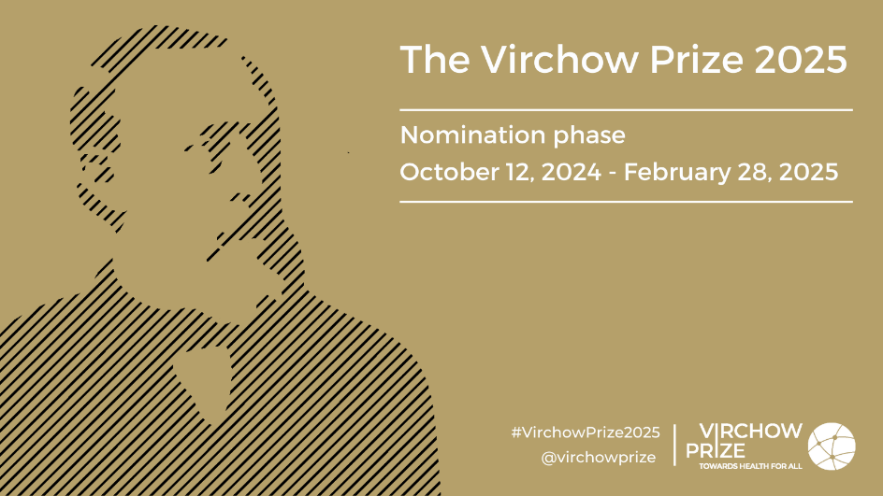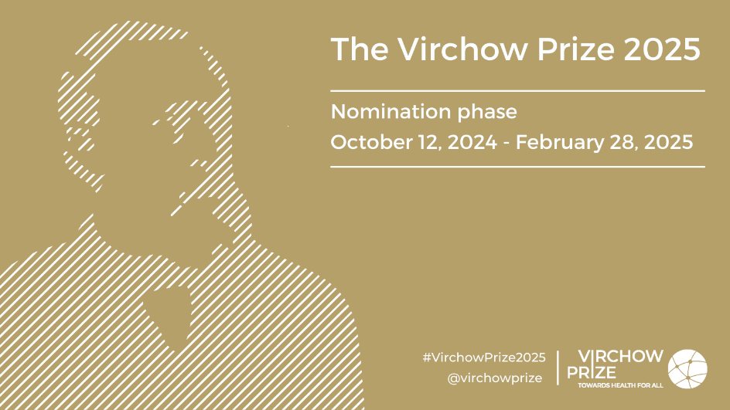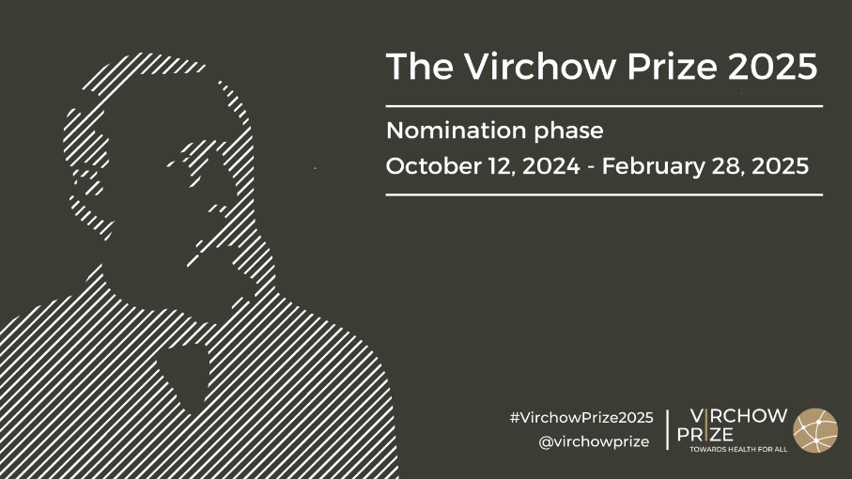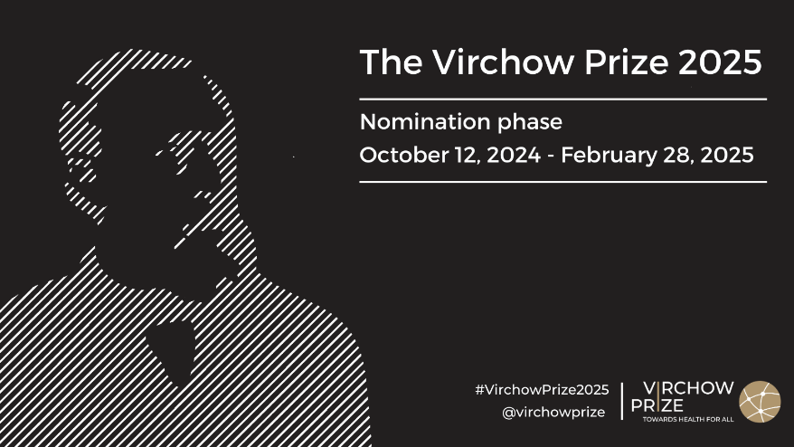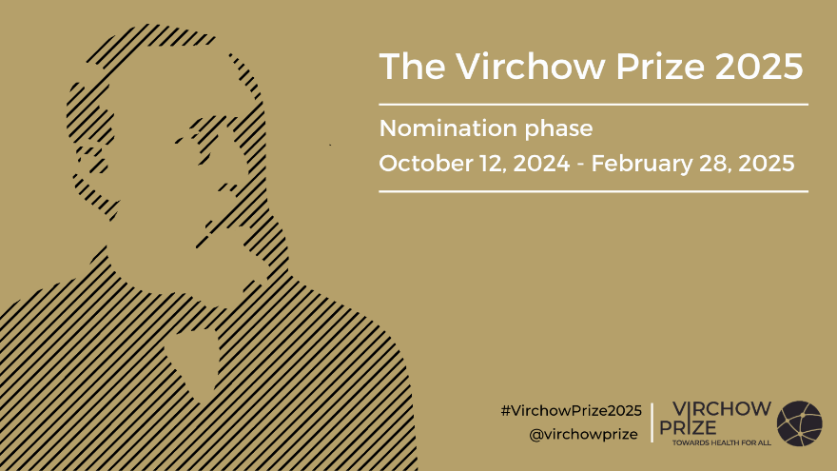

Virchow Prize for Global Health Logos

(Black text)

(White text)

Press Contact
For more information and/or material, please contact Steffi Gasteiger, Communication & Partnerships Manager, Virchow Foundation
steffi.gasteiger@virchow.foundation / press@virchow.foundation

